**Server Commission**

The following steps should be executed when commissioning a server.

* Confirm SQL Server has the latest Service Pack installed.
* Confirm the correct edition of SQL Server has been installed.

SELECT SERVERPROPERTY('Edition')

* Set Max Server Memory to approx 80% of total server memory for single instance servers.

sp_configure 'show advanced options' ,1

reconfigure

sp_configure 'max server memory (MB)',<80%>

* Set Backup Compression as default for instance.

sp_configure 'backup compression default',1

Reconfigure

* Enable Optimize for ad hoc workloads

sp_configure 'optimize for ad hoc workloads',1

Reconfigure

* Set Cost Threshold for Parallelism to 50

sp_configure 'cost threshold for parallelism',50

Reconfigure

* Confirm Instant File Initialisation is set. If not, add service account to Perform volume maintenance tasks
* Start – Admin Tools – Local Security Policy – Local Policies – User Rights Assignment - Perform volume maintenance tasks
* Enable Named Pipes and TCP/IP
  + Open Sql Server Configuration Manager - Expand SQL Server Network Configuration – Click on Protocols for <instancename> - Right mouse click on Named Pipes and enable. Repeat for TCP/IP.

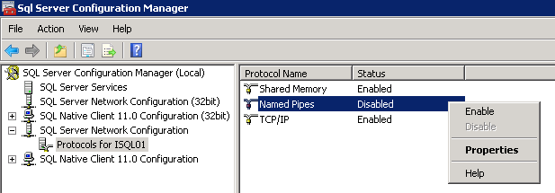

* Add trace flags 1222 (capture deadlocks) , 3226 (not log successful backup messages to the error log) and 1118 (<http://www.sqlskills.com/blogs/paul/misconceptions-around-tf-1118/>) as startup parameters.
  + Open Sql Server Configuration Manager - Click on SQL Server Services – Double click on SQL Server (<instancename>) – Choose the Startup Parameters tab (SQL 2012 only) – enter –T1222, –T3226 and –T1118 and press add

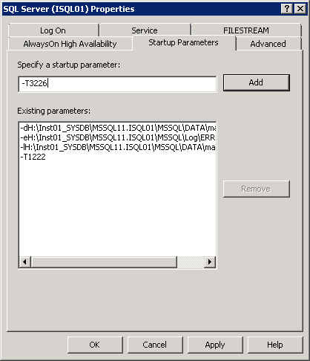

* Create default file locations.
  + <DataDrive>:

MKDIR MSSQL\<servername>\<version>\01_<instancename>\DATA01

<LogDrive>:

MKDIR MSSQL\<servername>\<version>\01_<instancename>\LOGS01

<SystemDrive>:

MKDIR MSSQL11_00.<instancename>\MSSQL\DATA

<TempdbDrive>:

MKDIR MSSQL\<servername>\<version>\01_<instancename>\DATA01

MKDIR MSSQL\<servername>\<version>\01_<instancename>\LOGS01

<BackupDrive>:

MKDIR MSSQL\<servername>\<version>\01_<instancename>\BACKUPS\DIFF

MKDIR MSSQL\<servername>\<version>\01_<instancename>\BACKUPS\FULL

MKDIR MSSQL\<servername>\<version>\01_<instancename>\BACKUPS\FULL_PRESERVE

MKDIR MSSQL\<servername>\<version>\01_<instancename>\BACKUPS\FULL_RESTORE_TEMP

MKDIR MSSQL\<servername>\<version>\01_<instancename>\BACKUPS\TLOG

*E.G.*

*F:*

*MKDIR MSSQL\K1STYSQLV02\11.00\01_ISQL01\DATA01*

*G:*

*MKDIR MSSQL\K1STYSQLV02\11.00\01_ISQL01\LOGS01*

*H:*

*MKDIR MSSQL11_00.ISQL01\MSSQL\DATA*

*T:*

*MKDIR MSSQL\K1STYSQLV02\11.00\01_ISQL01\DATA01*

*MKDIR MSSQL\K1STYSQLV02\11.00\01_ISQL01\LOGS01*

*Y:*

*MKDIR MSSQL\K1STYSQLV02\11.00\01_ISQL01\BACKUPS\DIFF*

*MKDIR MSSQL\K1STYSQLV02\11.00\01_ISQL01\BACKUPS\FULL*

*MKDIR MSSQL\K1STYSQLV02\11.00\01_ISQL01\BACKUPS\FULL_PRESERVE*

*MKDIR MSSQL\K1STYSQLV02\11.00\01_ISQL01\BACKUPS\FULL_RESTORE_TEMP*

*MKDIR MSSQL\K1STYSQLV02\11.00\01_ISQL01\BACKUPS\TLOG*

* Restore zzSQLServerAdmin database using the correct version model (DB is called SQLServerAdminModel - 2012 is on RCSTVMAN07). Change the database to ReadWrite and simple recovery mode.

N.B. If the instance isnt 2012 or the collation isnt set to Latin_General* then script out the database and apply via Management Studio.

RESTORE DATABASE zzSQLServerAdmin

FROM DISK = 'Y:\MSSQL\K1STYSQLV02\11.00\01_ISQL01\BACKUPS\FULL_RESTORE_TEMP\zzSQLServerAdminModel_FULL_20131107.bak'

with

move 'zzSQLServerAdmin' to 'F:\MSSQL\K1STYSQLV02\11.00\01_ISQL01\DATA01\zzSQLServerAdmin.mdf',

move 'zzSQLServerAdmin_log' to 'G:\MSSQL\K1STYSQLV02\11.00\01_ISQL01\LOGS01\zzSQLServerAdmin.ldf',

checksum

ALTER DATABASE zzSQLServerAdmin SET READ_WRITE

ALTER DATABASE zzSQLServerAdmin SET RECOVERY SIMPLE

ALTER AUTHORIZATION ON DATABASE::zzSQLServerAdmin TO sa;

* Remove stored procedures spBackupsFull_20xx and spBackupsLog_20xx relating to the version that hasn’t been installed.
* Update *zzSQLServerAdmin.dbo.tblConfigs* with relevant values.
* Create the following directories in the SQL error log directory

Powershell

Powershell\DriveStats

Powershell\DeleteBackupsDiff

Powershell\BackupDirSize

Audit

Audit\ServerRoles

Audit\LastLoginAudit

E.G

H:

MKDIR MSSQL11.ISQL01\MSSQL\Log\Powershell

MKDIR MSSQL11.ISQL01\MSSQL\Log\Powershell\DriveStats

MKDIR MSSQL11.ISQL01\MSSQL\Log\Powershell\DeleteBackupsDiff

MKDIR MSSQL11.ISQL01\MSSQL\Log\Powershell\BackupDirSize

MKDIR MSSQL11.ISQL01\MSSQL\Log\Audit\ServerRoles

MKDIR MSSQL11.ISQL01\MSSQL\Log\Audit\LastLoginAudit

* Move the DeleteBackups.ps1 file from

\\na01\Special_Projects\SQL_Server_Admin\ServerCommisioningScripts\

to the newly created Powershell directory

* Move the DriveStats.ps1 file from

\\na01\Special_Projects\SQL_Server_Admin\ServerCommisioningScripts\

to the newly created DriveStats directory

* Move the DeleteBackupsDiff.ps1 file from

\\na01\Special_Projects\SQL_Server_Admin\ServerCommisioningScripts\

to the newly created DeleteBackupsDiff directory

* Move the BackupDirectorySize.ps1 file from

\\na01\Special_Projects\SQL_Server_Admin\ServerCommisioningScripts\

to the newly created BackupDirSize directory

* Execute scripts in order below to create SQL Agent jobs, Operators and Alerts and any other processes outside of the zzSQLServerAdmin database. ALL SCRIPTS NEED TO BE OPENED AND THE VARIABLES SET TO THE CORRECT VALUES. Script 20 – HADRFailoverCheck is created in a disabled state. This needs to be changed if the instance contains a failover Availability Group. The scripts are located at...

\\na01\Special_Projects\SQL_Server_Admin\ServerCommisioningScripts\01 - AdminScript.sql

\\na01\Special_Projects\SQL_Server_Admin\ServerCommisioningScripts\02 - Alerts.sql

\\na01\Special_Projects\SQL_Server_Admin\ServerCommisioningScripts\03 - DBCCCheckDB.sql

\\na01\Special_Projects\SQL_Server_Admin\ServerCommisioningScripts\04 - IndexMaintenance.sql

\\na01\Special_Projects\SQL_Server_Admin\ServerCommisioningScripts\05 - CycleErrorLog.sql

\\na01\Special_Projects\SQL_Server_Admin\ServerCommisioningScripts\06 - BlockedSessions.sql

\\na01\Special_Projects\SQL_Server_Admin\ServerCommisioningScripts\07 - BackupDB.sql

\\na01\Special_Projects\SQL_Server_Admin\ServerCommisioningScripts\08 - Backup_Translog.sql

\\na01\Special_Projects\SQL_Server_Admin\ServerCommisioningScripts\09 - SpaceAlarms.sql

\\na01\Special_Projects\SQL_Server_Admin\ServerCommisioningScripts\10 DeleteRestoreFullTemp.sql

\\na01\Special_Projects\SQL_Server_Admin\ServerCommisioningScripts\12 - AutoGeneratedEmail.sql

\\na01\Special_Projects\SQL_Server_Admin\ServerCommisioningScripts\13 - LastServiceRestart.sql

\\na01\Special_Projects\SQL_Server_Admin\ServerCommisioningScripts\14 - Backup_Differential

\\na01\Special_Projects\SQL_Server_Admin\ServerCommisioningScripts\15 - Capacity.sql

\\na01\Special_Projects\SQL_Server_Admin\ServerCommisioningScripts\16 - LastLoginAudit.sql

\\na01\Special_Projects\SQL_Server_Admin\ServerCommisioningScripts\17 - LastLoginAudit_Job.sql

\\na01\Special_Projects\SQL_Server_Admin\ServerCommisioningScripts\18 - ServerRoles.sql

\\na01\Special_Projects\SQL_Server_Admin\ServerCommisioningScripts\19 - ServerRoles_job.sql

\\na01\Special_Projects\SQL_Server_Admin\ServerCommisioningScripts\20 – HADRFailoverCheck.sql

* Execute latest sp_whoisactive in master (Nov 2013 is v11.11). The script is located at...

\\na01\Special_Projects\SQL_Server_Admin\ServerCommisioningScripts\who_is_active_v11_11.sql

* Set default database, log and backup locations. (for versions < 2012, backup location needs to be set via xp_regwrite)

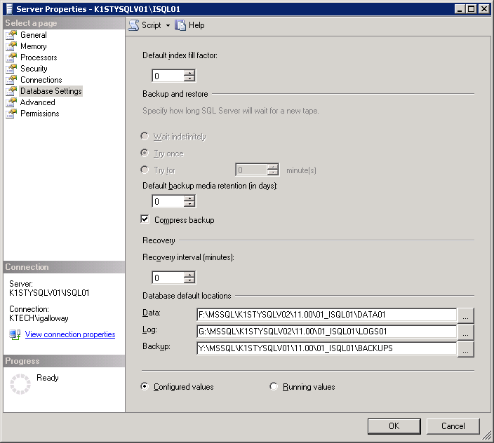

* Split Tempdb into as many data files as cores up to 8. Set the filesizes to be equal, taking up 70% of the disk and disable autogrow.

ALTER DATABASE tempdb

modify file (NAME = tempdev, SIZE = x,

FILEGROWTH = 0MB);

ALTER DATABASE tempdb

ADD FILE (NAME = tempdev1, FILENAME = 'T:\MSSQL\10.50\00_MSSQLSERVER\DATA01\tempdb2.mdf', SIZE = x,

FILEGROWTH = 0MB);

ALTER DATABASE tempdb

modify file (NAME = templog, SIZE = 1000,

FILEGROWTH = 100MB);

* Create Machine folder on na01

\\na01\special_projects\SQL_Server_Admin\Machines\<MachineName>\<InstanceName>

* Disable SA login.

ALTER LOGIN sa DISABLE

* Create SystemsAdministrator login with sysadmin privs.

CREATE LOGIN [SystemsAdministrator]

WITH PASSWORD=N'',

DEFAULT_DATABASE=[master],

DEFAULT_LANGUAGE=[British],

CHECK_EXPIRATION=OFF,

CHECK_POLICY=OFF

GO

EXEC sys.sp_addsrvrolemember

@loginame = N'SystemsAdministrator',

@rolename = N'sysadmin'

GO

* Confirm SQL_Admins is added as sysadmin.
* Add SQL services account and SystemAdministrator account details and password into KeePas.
* Add commissioning backups of Master; Model; msdb; created and stored in \\na01

DECLARE @BackupLocation varchar(1024) = (SELECT [Value] FROM [zzSQLServerAdmin].[dbo].[tblConfigs] WHERE Name = 'Full_Preserve_BackupLocation')

DECLARE @MasterBackupLocation varchar(1024) = @BackupLocation + '\CommissioningBackups\master.bak'

DECLARE @msdbBackupLocation varchar(1024) = @BackupLocation + '\CommissioningBackups\msdb.bak'

DECLARE @modelBackupLocation varchar(1024) = @BackupLocation + '\CommissioningBackups\model.bak'

backup database master

to disk = @MasterBackupLocation

backup database model

to disk = @modelBackupLocation

backup database msdb

to disk = @msdbBackupLocation

* Run CrystalDiskMark on all drives to get a baseline reading for IO. CrystalDiskMark is located at...
* \\na01\Special_Projects\SQL_Server_Admin\CrysalDiskMark
* Configure database mail. Ensure the account/profile name follow the Ghost_<SERVERNAME> naming convention.

sp_configure 'Database Mail XPs',1

RECONFIGURE

Remember to Enable the Mail profile in SQL Server Agent Properties and restart SQL Agent

* Contact INFRA team make changes to firewall/ports to allow mail to be sent from the server.
* Contact INFRA team to make changes to the firewall to allow PING and WMI access from RCSTVMAN07, if server is located on ATDRUK domain.
* ALTER model database to set the initial filesize and growth for the data and log files.

ALTER DATABASE model

MODIFY FILE

(

NAME = modeldev,

SIZE = 100,

FILEGROWTH = 1024

);

GO

ALTER DATABASE model

MODIFY FILE

(

NAME = modellog,

SIZE = 50,

FILEGROWTH = 1024

);

GO

* Backup Server Master Key to

\\na01\Special_Projects\SQL_Server_Admin\MACHINE\<InstanceName>\ServiceMasterKey\<InstanceName>_ServiceMasterKey.bak

BACKUP SERVICE MASTER KEY

TO FILE = '<FileLocation>\<InstanceName>_ServiceMasterKey.bak'

ENCRYPTION BY PASSWORD = <PASSWORD>

Store the password in KeePass as ServiceMasterKey

* Manually execute all DBA Maintenance SQL Agent Jobs and confirm they complete successfully.
* Check Powershell error logs and confirm no error messages are being created
* Check zzSQLServerAdmin.dbo.CommandLog for Index and CheckDB messages
* Check zzSQLServerAdmin.dbo.tblDriveStats is populated
* Check zzSQLServerAdmin.dbo.tblBackupDirectorySize is populated
* If server inventory script isnt enabled on the instance, enter the details into the STATIC server inventory table on RCSTVMAN07.

INSERT INTO [zzSQLServerAdmin].[dbo].[tblServerStatsAll_STATIC]

VALUES ('',CURRENT_TIMESTAMP,'','','','','','','','',’’,’’)